H.T No
Regulations:
A18

Sreenidhi Institute of Science and Technology
(An Autonomous Institution)
Code No: 7KC86 Date: 15-July-2023 (FN)

B.Tech III-Year II- Semester External Examination, July - 2023 (Supplementary)
FOUNDATION ANALYSIS AND DESIGN (CIVIL)

Time: 3 Hours Max.Marks:70

Note: a) No additional answer sheets will be provided.
b) All sub-parts of a question must be answered at one place only, otherwise it will not be valued.
c) Missing data can be assumed suitably.

Bloom's Cognitive Levels of Learning (BCLL)

Remember | L1 | Apply | L3 | Evaluate | L5
Understand | L2 | Analyze | L4 | Create | L6

Part - A Max.Marks:20
Answer all QUESTIONS

 |  | BCLL | CO(s) | Marks
1 | Define area ratio. | L2 | CO1 | [2M]
2 | What is Passive Earth Pressure? | L1 | CO2 | [2M]
3 | Define shallow foundation. | L2 | CO3 | [2M]
4 | What are the various types of settlements in foundations? | L1 | CO4 | [2M]
5 | Write Engineering News Record formula for load carrying capacity of piles. | L1 | CO5 | [2M]
6 | Define scouring. | L2 | CO6 | [2M]
7 | What is Reconnaissance? What is its use? | L1 | CO1 | [2M]
8 | Define significant depth. | L2 | CO3 | [2M]
9 | What are methods to determine the load carrying capacity of a pile? | L1 | CO5 | [2M]
10 | What is the Factor of Safety against Sliding for retaining wall? | L1 | CO2 | [2M]
Part – B Max.Marks:50
ANSWER ANY FIVE QUESTIONS. EACH QUESTION CARRIES 10 MARKS.

 |  |  | BCLL | CO(s) | Marks
11. | a) | What do you understand site investigation? Discuss the preliminary steps involved in site investigation. | L2 | CO1 | [5M]
 | b) | Explain the Wash boring with a neat sketch. | L2 | CO1 | [5M]
12. | a) | Determine the rankine’s active earth pressure on the retaining wall shown below. Also determine the location of resultant earth pressure. Take unit weight of water = 10 kN/m³.  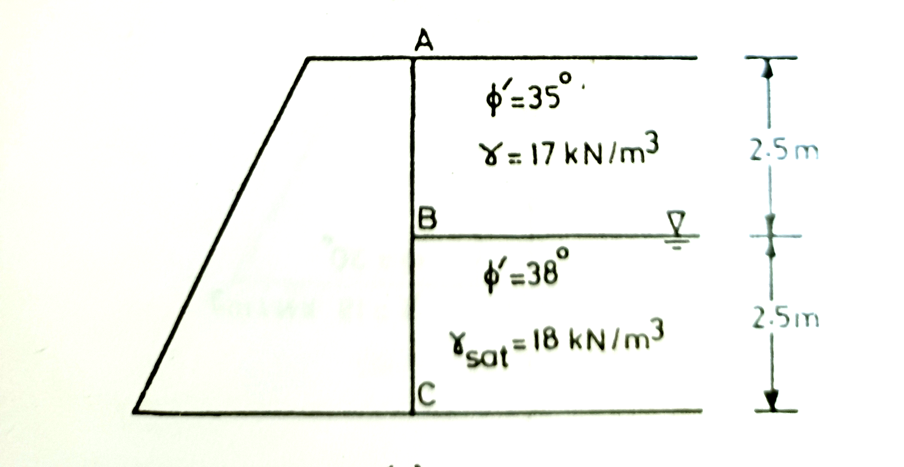 | L4 | CO2 | [5M]
 | b) | What are the assumptions in coulomb’s theory? Compare Rankine’s theory and coulomb’s theory? | L2 | CO2 | [5M]
13. | a) | What are the different types of shallow foundations? Explain with the help of sketches. | L2 | CO3 | [5M]
 | b) | Describe the procedure of determining the safe bearing capacity based on standard penetration test. | L2 | CO3 | [5M]
14. | a) | Explain briefly about the various causes of settlement of foundation. | L2 | CO4 | [5M]
 | b) | A rectangular footing 3 m x 2 m size, exerts a pressure of 100 kN/m² on a cohesive soil (E = 5*10⁴ kN/m² and μ = 0.5. Determine the immediate settlement at the center, assuming the footing to be rigid. | L3 | CO4 | [5M]
15. | a) | How will you estimate the load carrying capacity of a pile in cohesionless soil and cohesive soil. | L3 | CO5 | [5M]
 | b) | What is deep Foundation? Explain different types of materials used for pile foundation their significance and usage. | L2 | CO5 | [5M]
16. | a) | What are the various components of a well foundation? What are their uses? | L2 | CO6 | [5M]
 | b) | Explain the measures for rectification of tilts and shifts in well foundation. | L2 | CO6 | [5M]
17. | a) | Compare the difference between SPT and DCPT test. | L2 | CO1 | [4M]
 | b) | How do you check the stability of retaining walls? | L2 | CO2 | [3M]
 | c) | What are assumptions in terzaghi’s bearing capacity theory? | L2 | CO3 | [3M]
18. | a) | What is settlement of footing as per plate load test? | L2 | CO4 | [4M]
 | b) | What are the factors consider while selecting the type of pile? | L2 | CO5 | [3M]
 | c) | What are the forces acting on well foundation? | L1 | CO6 | [3M]
-- 00 -- 00 –

